### GAP LIST

…

#### #14368: SALESMAN AND CUSTOMER DAILY TARGET

1. **Overview:**

* User sets up monthly target for customer base on monthly target of salesman

1. **User Requirement:**

* User sets up monthly target for salesman and customer
* On PDA, salesman can see their own daily target and daily target of customer
  + Daily target = ( monthly target – achievement of customer ) / (number of visit left on current month)
  + Achievement of customer = Finished + in processing order
* Suggested daily target of salesman and customer can’t be changed on PDA

1. **Process:**



1. **List of use case:**

* **Use case 01:** Set up salesman monthly target
* **Use case 02:** Set up customer monthly target
* **Use case 03:** Show salesman and customer daily target on PDA

1. **Assumption**
2. **Impact**

* Core: new function of setting up customer monthly target
* PDA: new function of showing customer daily target on PDA

##### UC01: Set up salesman monthly target

|  |  |
| --- | --- |
| **Brief description** | This use case is run when user sets up monthly target of each brand for salesman |
| **Actor** | User who has the following permission(s)   * Set up monthly target of each brand for salesman |
| **User Goal** | * Monthly target of each brand is set up for each salesman |
| **Preconditions** | * User logged in successfully * User has permission to do this action |
| **Post-conditions** | Monthly target of each brand for salesman is set up successfully |
| **Trigger** | User wants to set up monthly target of each brand for salesman |

* **Main Success Scenario:**

1. User assigns KPIs for salesman by sales group
2. System saves information and applies for PDA

* **Alternative:**

1a. User changes KPIs for salesman by sales group of each brand

1a.1. System saves changed information and applies for PDA

* **Business Rules:**

1.

* User selects salesman who belongs to sales group (mapping with route)
* User has to set up target for sales group first and then can set up target for each brand of that sales group
* Sum of brand’s target can’t be greater than target of sales group
* User can upload target by excel file

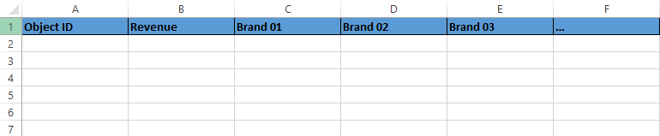

###### Screen 01 (SAP): Set Up Salesman Monthly Target

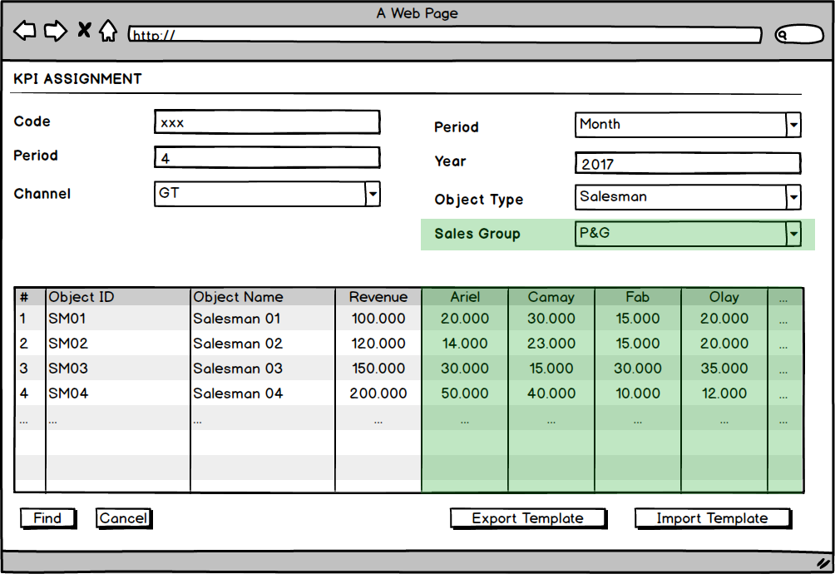

* **Screen Description**

|  |  |  |  |  |
| --- | --- | --- | --- | --- |
| **Element** | **Type** | **Length** | **Default Value** | **Description and Rules** |
| Sales Group | Combo Box |  | Blank | Selects sales group |
| Brand (Ariel, Camay, Fab, Olay, …) | Number |  | Blank | Brands of selected sales group  Sales group target has to be set up first to set up the brand target  Sum of brand’s target can’t be greater than target of sales group |

##### UC02: Set up customer monthly target

|  |  |
| --- | --- |
| **Brief description** | This use case is run when user sets up monthly target for customer (base on salesman monthly target) |
| **Actor** | User who has the following permission(s)   * set up monthly target for customer |
| **User Goal** | * Monthly target is set up for each customer |
| **Preconditions** | * User logged in successfully * User has permission to do this action * Salesman monthly target has been set up |
| **Post-conditions** | Monthly target for each customer is set up successfully |
| **Trigger** | User wants to set up monthly target for each customer base on salesman monthly target |

* **Main Success Scenario:**

1. User selects salesman, month and year which has been set up monthly target for salesman in use case 01
2. System show route and target of salesman
3. User clicks on “Generate Customer Target” button
4. System auto generates suggested target for each customer in route base on percent revenue contribution in last 3 months
5. User adjusts the target of each customer and clicks “Add” button
6. System saves information of customer monthly target

* **Alternative:**

2a. If salesman doesn’t manage any route

2a.1. “Route” is blank

2a.2. User click on “Generate Customer Target” button

2a.3. System shows an alert “Salesman doesn’t manage a route yet”

2a.4. User re-selects the salesman or gets back to route master and selects route which is managed by the salesman

2b. If salesman hasn’t been set up a monthly target yet

2b.1. “Salesman’s target” is blank

2a.2. User click on “Generate Customer Target” button

2a.3. System shows an alert “Salesman monthly target hasn’t been set up yet”

2a.4. User re-selects the salesman or gets back to set up monthly target for salesman

5a. User can export monthly target of each customer and to excel file and modify. After that, user can import the monthly target by modified excel file

* **Business Rules:**

1.

* Route is selected in route master which managed by salesman
* Salesman’s target is selected in use case 01 – set up salesman monthly target

4. System shows the list of customer in route. User can’t change the customer in this screen (user just can change in route setting)

###### Screen 01: Customer Monthly Target (SAP)

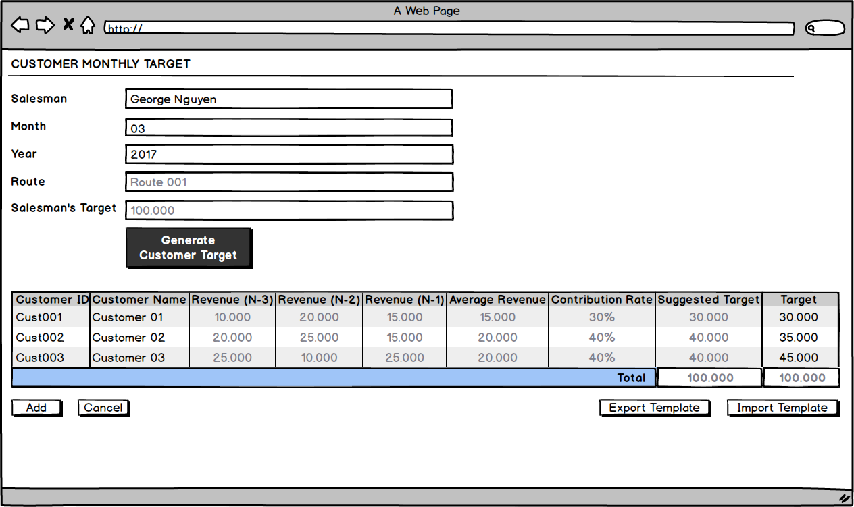

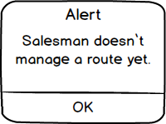

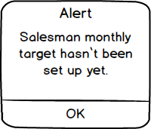

* **Screen Description**

|  |  |  |  |  |
| --- | --- | --- | --- | --- |
| **Element** | **Type** | **Length** | **Default Value** | **Description and Rules** |
| Salesman | Text box |  | Blank | User selects salesman |
| Month | Number |  | Blank | User selects month |
| Year | Number |  | Blank | User selects year |
| Route | Text box |  | Blank | Route that managed by the salesman  If salesman doesn’t manage any route yet, this information is blank |
| Salesman’s Target | Number |  | Blank | Target of salesman base on month and year have been selected  If salesman hasn’t set up monthly target yet, this information is blank |
| Generate Customer Target | Button |  |  | System auto generates the customer target base on percent revenue contribution in last 3 months   * If “Route” is blank, system shows an alert “Salesman doesn’t manage a route yet.” * If Salesman’s Target is blank, system shows an alert “Salesman target hasn’t been set up yet.” |
| Customer ID | Text |  | Blank | Customer ID in route |
| Customer Name | Text |  | Blank | Customer Name in route |
| Revenue | Number |  | Blank | Revenue of customer in route in last 3 months |
| Average Revenue | Number |  | Blank | Average of revenue in last 3 months  = [ **Revenue (N-1)** + **Revenue (N-2)** + **Revenue (N-3)** ] / 3 |
| Contribution Rate | Percent |  | Blank | Percent revenue contribution of customer  = ( **Average Revenue** / **Sum of average revenue** ) * **100%** |
| Suggested Target | Number |  | Blank | Suggested target for customer  = **Contribution Rate** * **Salesman’s target** |
| Target | Number |  | Blank | Target of customer  = **Suggested target by default**  User can change this target directly or by excel file |
| Total | Number |  | Blank | Sum of Suggested target or Target |
| Add | Button |  |  | Save customer monthly target |
| Cancel | Button |  |  | Cancel and don’t save any information |
| Export Template | Button |  |  | Export customer target in excel file. User can adjust the target and upload later by “Import template” button |
| Import Template | Button |  |  | Import the customer monthly get by excel file which has been exported |

##### UC03: Show salesman and customer daily target on PDA

|  |  |
| --- | --- |
| **Brief description** | This use case is run when salesman views his/her daily target and customer daily target on PDA |
| **Actor** | * Salesman |
| **User Goal** | * Salesman can view his/her daily target and customer target on PDA |
| **Preconditions** | * Salesman and customer monthly target have been set up on use case 01 + 02 * User logs in and visits customer |
| **Post-conditions** | Salesman can view his/her daily target and customer target on PDA |
| **Trigger** | User wants to view his/her daily target and customer daily target on PDA |

* **Main Success Scenario:**

1. Salesman views his/her daily target on PDA
2. PDA shows salesman daily target
3. Salesman views customer daily target on PDA
4. PDA shows customer daily target

* **Alternative:**

* **Business Rules:**

###### Screen 01: Salesman Daily Target (PDA)

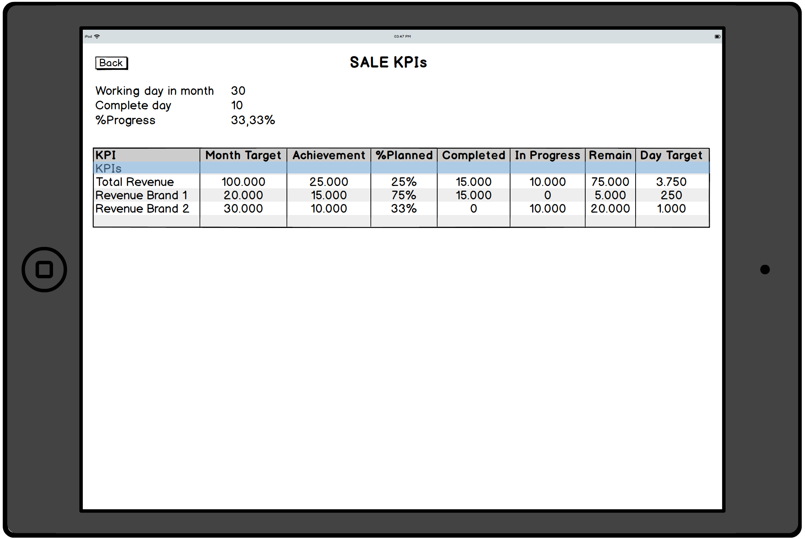

* **Screen Description**

|  |  |  |  |  |
| --- | --- | --- | --- | --- |
| **Element** | **Type** | **Length** | **Default Value** | **Description and Rules** |
| Back | Button |  |  | Get back to main menu |
| Working day in month | Number |  | Blank | Working day in month |
| Complete day | Number |  | Blank | Complete day in month |
| %Progress | Percent |  | Blank | = ( Complete day / Working day in month ) * 100% |
| KPIs | Text |  | Blank | List of KPIs |
| Month Target | Number |  | Blank | Month target – set up in SAP |
| Achievement | Number |  | Blank | = Amount of sales order has processed to A/R invoice + Amount of sales order is processing |
| %Planned | Percent |  | Blank | = ( Achievement / Month Target ) * 100% |
| Completed | Number |  | Blank | Amount of Sales order has processed to A/R invoice |
| In progress | Number |  | Blank | Amount of Sales order is processing |
| Remain | Number |  | Blank | = Month Target – Achievement |
| Day Target | Number |  | Blank | = Remain / ( Working day in month – Complete day ) |

###### Screen 02: Customer Daily Target (PDA)

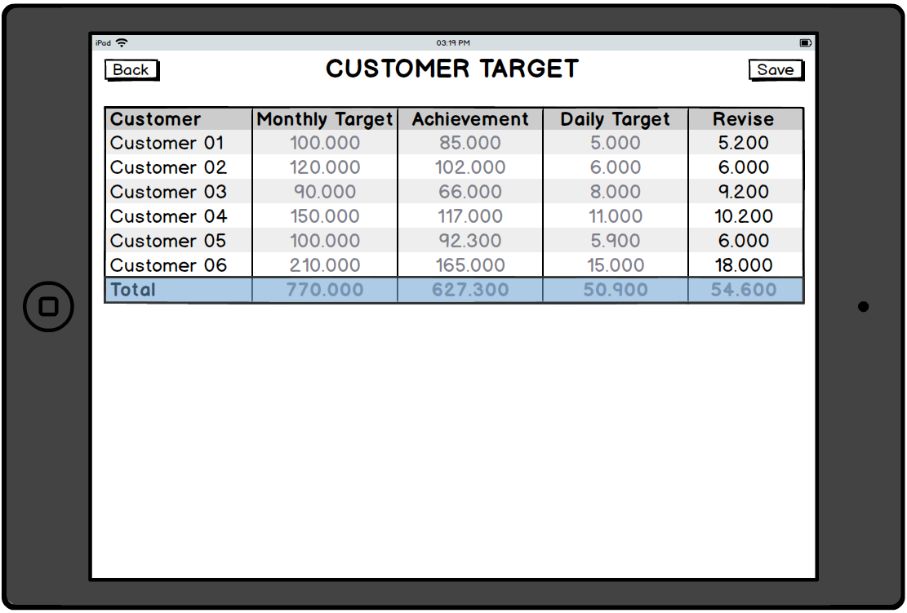

* **Screen Description**

|  |  |  |  |  |
| --- | --- | --- | --- | --- |
| **Element** | **Type** | **Length** | **Default Value** | **Description and Rules** |
| Customer | Text |  | Blank | In-route customer of salesman |
| Monthly Target | Number |  | Blank | Monthly target is collected from use case 02 – set up customer monthly target |
| Achievement | Number |  | Blank | = Amount of sales order has processed to A/R invoice + Amount of sales order is processing |
| Daily Target | Number |  | Blank | Daily Target = ( Monthly Target – Achievement of customer ) / the number of visit call left on current month |
| Revise | Number |  | Blank | Salesman can revise the daily target of customer  Revise = Daily target by default |
| Back | Button |  |  | Get back to main menu |
| Save | Button |  |  | Save the revise of salesman |